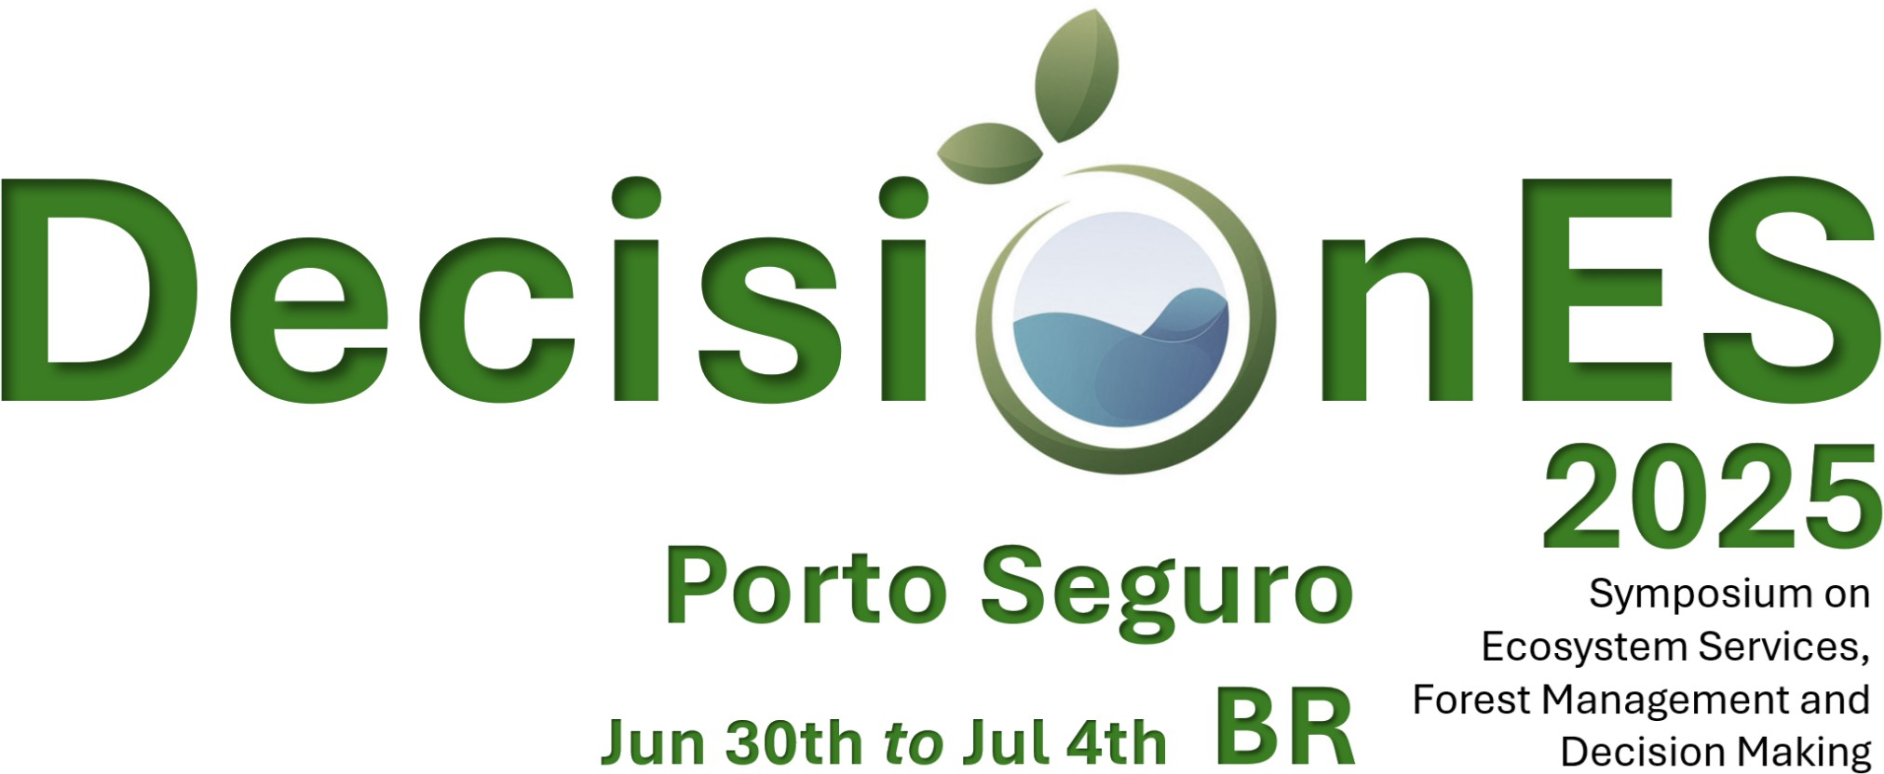

Program
DecisionES_BR2025 is pleased to offer you 4 days of plenary sessions, keynote speakers and social activities. The conference will include a field trip. More information will continue to be added to this page as the program develops.
Abstract submission is now closed.
The symposium will officially start on July 1st and last until July 4th. The arrival and registration of attendants is expected to be on
Monday 30th of June 2025 at 18:00 where registered researchers will be invited to a wellcoming cocktail and dinner included with the registration.

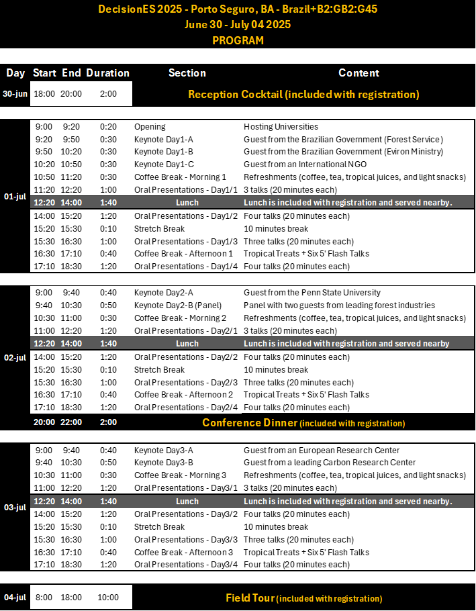
Here will be posted the guide for participants (including the agenda and list of abstracts).

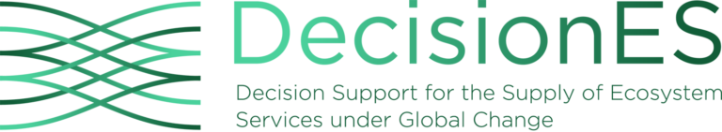

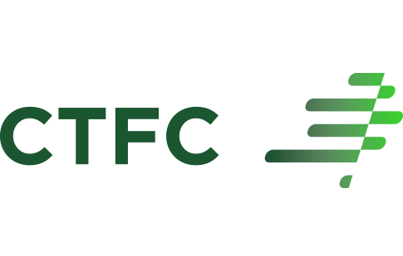

© DECISIONES, 2023 · Data protection and privacy policy · Contacts Neve | Powered by WordPress

